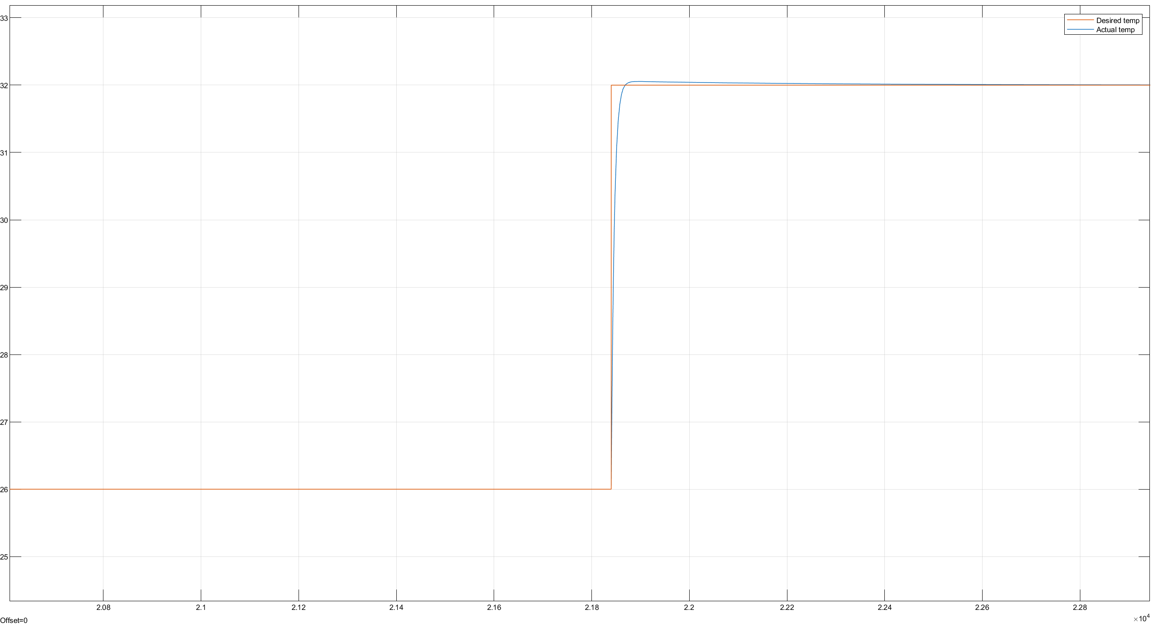

Figure : Critical point ambient temp

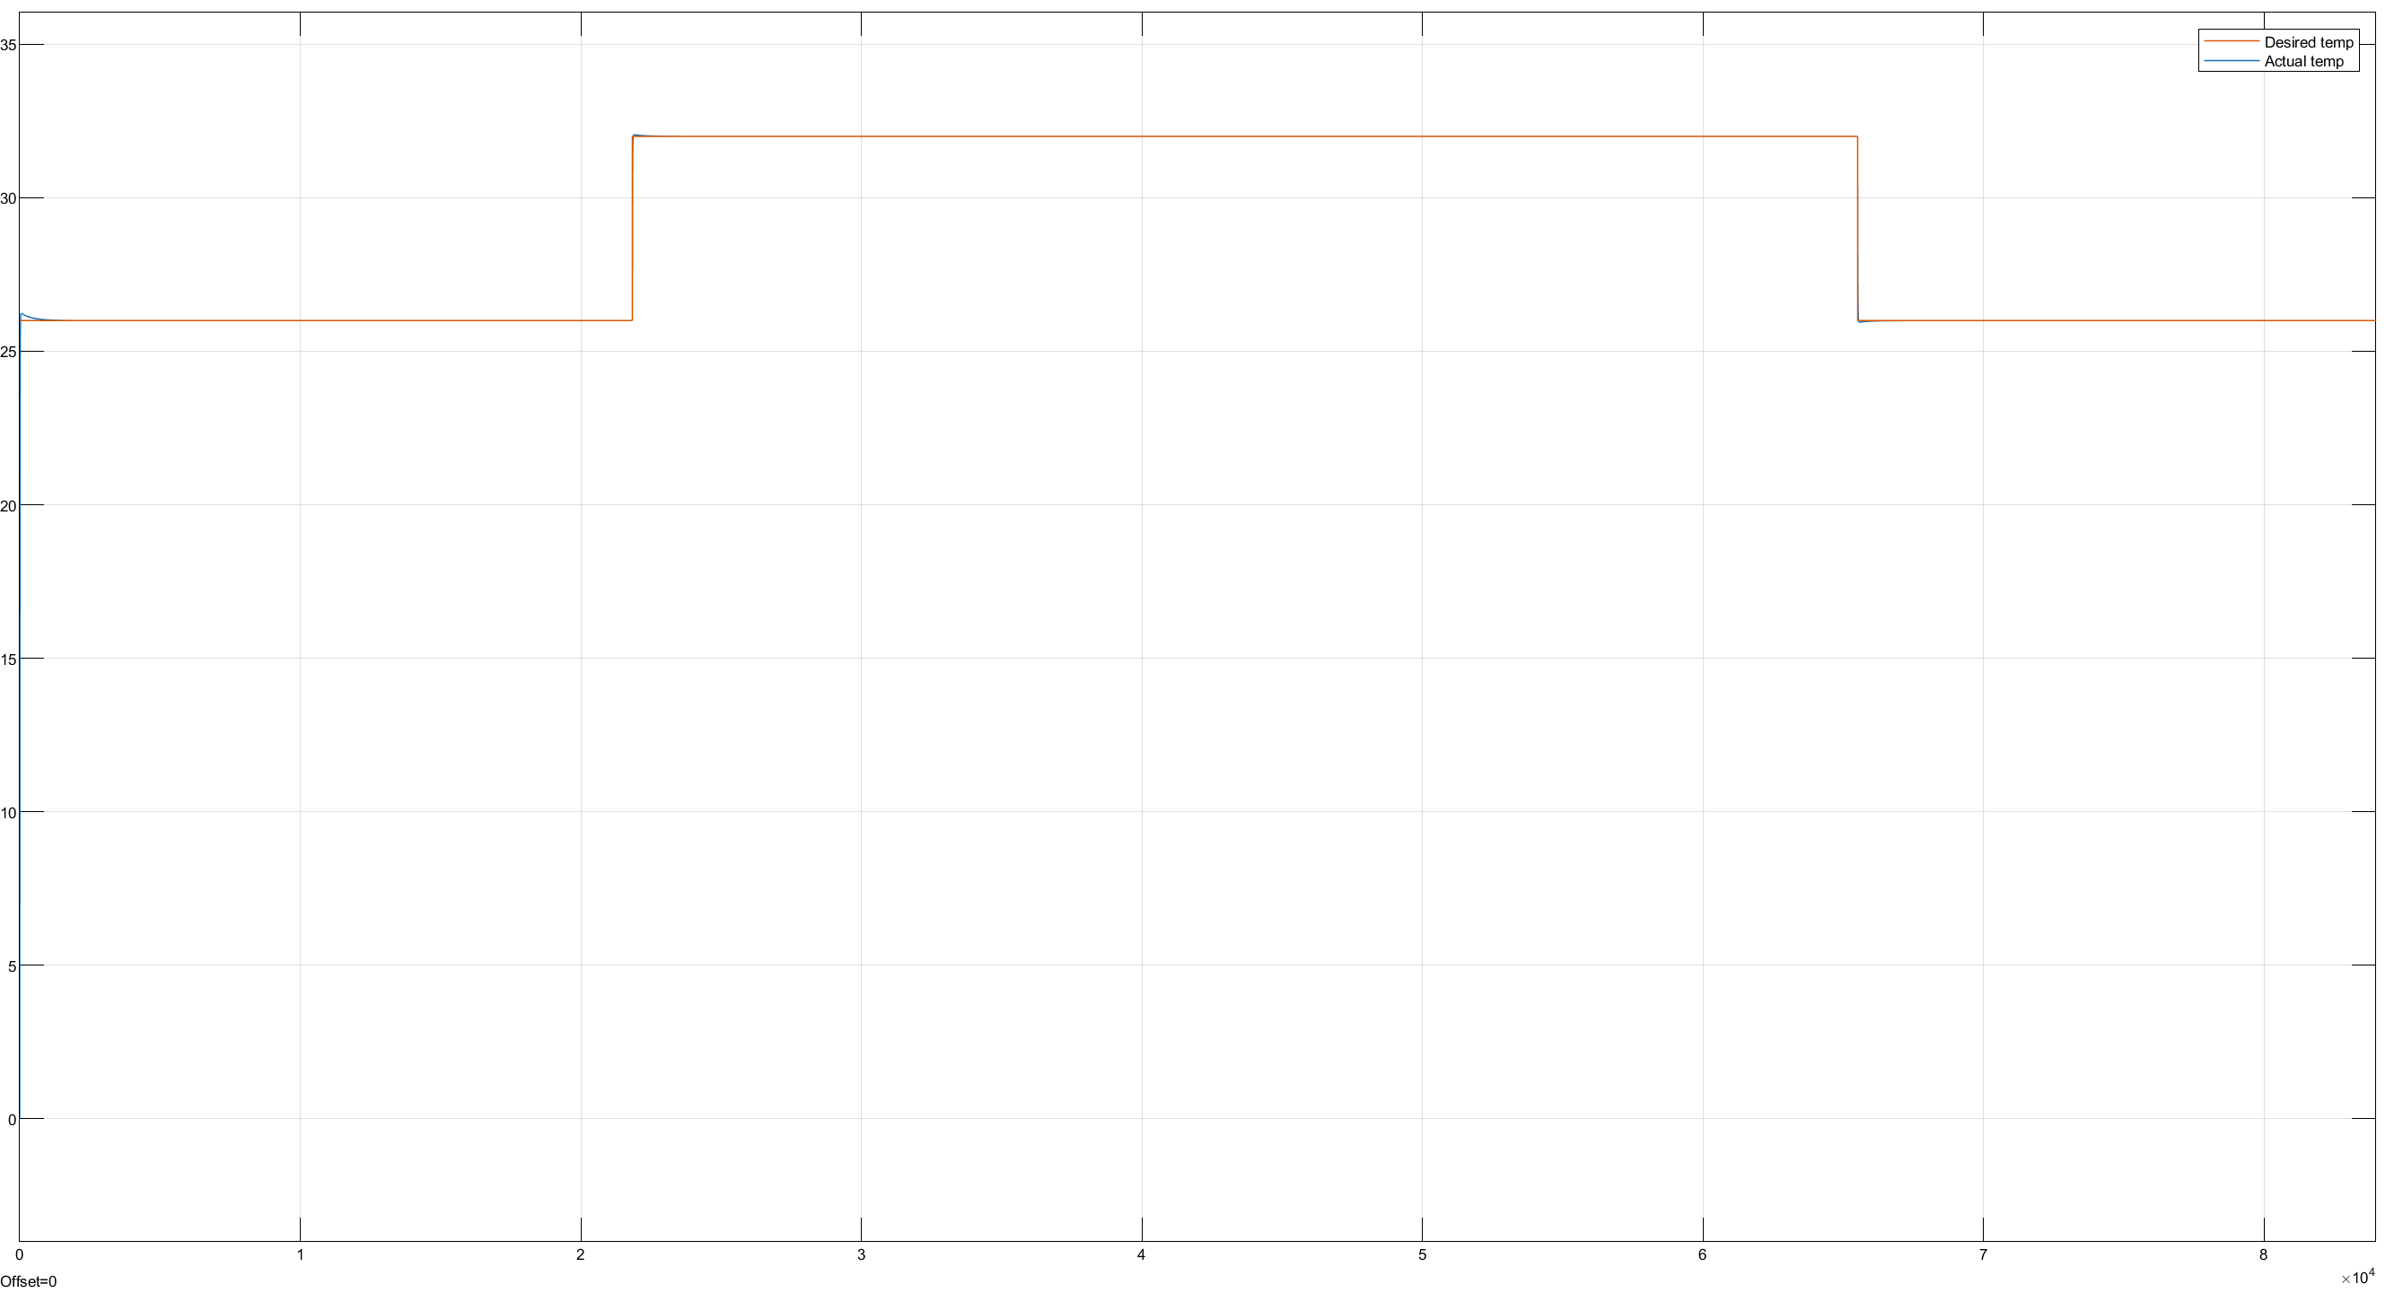

Figure : Day timeframe ambient temp

Figure : Simulink temperature function

Figure : Ambient temp over whole year

Figure : Humidity control with disruption (humidity decreasing to 0.4 (low natural UK humidity)) over one day